Digital Audio Workstation
Pennwest California

Specification Document

CSC 4900 – Senior Project I

Group Members
Clayton Sanner
Brandon Smith
Alice Bruce
Instructor Comments/Evaluation 92
Overall a great specification document that included all required components.
User interaction, user cases and scenarios were clearly specified. Class diagrams were well presented. User acceptance criteria were listed in a good format.
References were included in a good format.

Things to improve:
- Sequential diagram needs improvement.
- Missing some citation e.g., Smith B spotify

See other comments in text.

Table of Contents
Abstract---------------------------------------------------------------------------------------------------------5
Document Description----------------------------------------------------------------------------------------5
Purpose and Use--------------------------------------------------------------------------------------5
Intended Audience-----------------------------------------------------------------------------------6
System Description-------------------------------------------------------------------------------------------6
Overview----------------------------------------------------------------------------------------------6
Environment and Constraints-----------------------------------------------------------------------7
End User Profile-----------------------------------------------------------------------------7
User Interaction------------------------------------------------------------------------------7
Hardware Constraints----------------------------------------------------------------------8
Software Constraints-----------------------------------------------------------------------8
Time Constraints---------------------------------------------------------------------------9
Cost Constraints----------------------------------------------------------------------------9
Other Concerns-----------------------------------------------------------------------------10
Acceptance Test Criteria---------------------------------------------------------------------------10
Testers--------------------------------------------------------------------------------------10
Criteria for User Acceptance------------------------------------------------------------11
Integration of Separate Parts and Installation---------------------------------------------------12
System Modelling--------------------------------------------------------------------------------------------12
Functional: Use Cases & Scenarios--------------------------------------------------------------12
Entity:Class Diagrams-----------------------------------------------------------------------------13
Class name / Description / Type---------------------------------------------------------14 Attributes------------------------------------------------------------------------------------14
Dynamic StateChart--------------------------------------------------------------------------------16
States----------------------------------------------------------------------------------------16
Events---------------------------------------------------------------------------------------16
Transitions----------------------------------------------------------------------------------18
Dataflow------------------------------------------------------------------------------------------------------20
Components/Tools Needed---------------------------------------------------------------------------------21
Citations-------------------------------------------------------------------------------------------------------22
Appendix: Glossary------------------------------------------------------------------------------------------22
Appendix: Team Details------------------------------------------------------------------------------------24
Appendix: Workflow Authentication---------------------------------------------------------------------25
Appendix: Writing Center Report-------------------------------------------------------------------------26

Abstract
The Digital Audio Workstation is intended to help musical artists and composers by providing software to create music using different synthetic instruments and individual tracks for each instrument that can be stacked to play at the same time which are saved as MIDI files that can also be imported into the program for editing. While many exiting DAWs provide these features, they tend to be very complex and complicated to use and are expensive for individuals. Existing DAWs are usually very complex and complicated software which takes a lot of time simply to learn and understand all the functions they provide while also having prices in range of $100-200(Create your best music, Creative tools for music makers). The team aims to provide these common features while providing a much more affordable, user-friendly, and easily available option. The creation of this software will provide a lower barrier to entry for amateur and professional music creation
Document Description
Purpose and Use
This document outlines the scope and the requirements of the project such as its environment and models along with intended use. It will be used as a key reference for development and the user and, or client to understand the terms of the agreement in the development. Through the details in this document, you will be able to find the constraints and long-term planning for the development of this project and use that to determine any uncertainty and desired outcome of the project. Once the terms of this document are accepted it will act as a binding contract.
Intended Audience
The intended audience for this document includes the developers as well as the clients involved. Clients will be able to view this document to make sure that the product does or does not fulfil requirements. If the document does not meet their needs or expectations, it is the responsibility of the developers to revise the document until an appropriate compromise is met. This is important because it will be the developer’s guideline throughout the project to meet the client’s needs
System Description
Overview
The Objective of our DAW is to create a user-friendly, affordable, and highly compatible software. This will create a comfortable and easy to use space for musicians and composers while having a low learning curve to get the most out of the software. It will include compatibility with peripheral devices such as MIDI instruments, voice recordings, and proper usage of file systems for exporting and importing files from the software. This will all be achieved through the use of the coding language C++ as the backbone of the program, MySQL for formatting the file systems, pre-existing libraries for synthetic instruments, audio recordings and peripheral devices. To make the program easy to learn and user-friendly we plan to include tutorials throughout the program that can be found simply by hovering over buttons or settings while also designing the software from the perspective of a user who knows nothing of these programs. The program will be made affordable because we will not be charging for it and the files will be made open source.
Environment and Constraints
End User Profile
The end-user profile for the Digital Audio Workstation will include music composers and hobbyists who are in need of simple, efficient and affordable software to perform their jobs and, or hobby. As they edit and produce music for commercial or personal use. A tool is needed to allow them to save, import, export, and manipulate the music in the different ways including both manipulation of the track and timelines as well as the addition of midi sounds. With the major goal of the digital audio workstation is to both to refine music for other uses so it needs to be operational in all these aspects to provide all of these user needs.

User interaction
User interaction will be split into two, the interaction done through software interface and interaction done through peripheral inputs. Through the software users will be working within a graphical user interface to manipulate audio and midi files with which the user will be able to edit in several different ways. This will be done through a series of menus that the user will navigate through to manage settings, import and export files, save changes to files as well as manipulate digital representations of tracks and instruments to add and manipulate audio. As for the peripheral input interaction, this will be where a user will connect something such as a midi instrument or a microphone or another supported peripheral which will be supported and seen through the interface. You will be able to provide input with by either recording audio through a microphone or manipulating the audio through the instrument.
Hardware Constraints
The minimum hardware constraint would simply be to have a PC that can run the software itself and some form of speaker to hear the audio. The software will support several other pieces of hardware to be used within the program which includes microphones and midi instruments. There are also some more obvious constraints in relation to the fact this is a PC specific software so you will mainly be interfacing into it through a mouse and keyboard to perform actions on the program as well as there might be some form of touch pad implementation for PCs that can switch into a touchpad format. As well you will originally need a stable internet connection to download the software but after that it will not be required as the program will be running locally
Software Constraints
Major software constraints are mostly confined to internet access, access to a browser, and a simple file explorer. This software will be confined to personal computers so it will not be functional as a mobile application. You will be able to download the software from our git repository which will then have an exe that can run the program on the user’s personal computer. You will mainly just need to be able to access some form of browser i.e. Chrome, Microsoft edge, or some equivalent. Besides those needs, the developers will need access to simple programming languages such as C++, data management software as MySql, and libraries to support peripheral items in the software.

Time Constraints
The time constraints on this project follow an academic semester which consists of 15 weeks to finish this project to a satisfactory degree. This means that the developers of this project will be devoting several hours every week to developing, testing, and documenting the progress of this project. Though because of this being centered around a college course and schedule other responsibilities such as other classes, jobs, and personal responsibilities must be taken into account in relation to how much of our time can be focused on this project solely. The team will still do whatever is in our power to make the best use of our time and resources that we can. There is also an understanding through the group and should be specified to any client and or user that traditionally Digital audio workstations are very large and complex software’s made by large teams with a much larger development time and of an equally high cost. Due to these time constraints and having a realistic understanding of the developers skills and allocatable time an open-source model will be a key feature of the software so that the team may be able to continue working on the software and allow for users to make changes and adjustments to the base of the program to further meet needs while under a unrealistic time restraint for a commercial product of this size and quality.
Cost Constraints
The cost constraints of this project will be kept as low as possible to account for our promise of making an open-source, affordable, and widely available software. For individual users the cost should be kept mostly to the price of a computer and or laptop with options to allow for the use of certain specific peripherals such as mic and or instruments. Due to this the cost constraint for the average user could vary largely. A user will at minimum need a computer with the ability to run the software which should be within the range of $500-$800. If they would also like to include midi instruments a keyboard average at around $100. As for a microphone, its price will depend largely on the users’ intended projects with the software so it can vary widely.
In regard to development costs, it will still be kept as low as possible as our team plans to use free and easily available tools to create the software. As well due to the nature of open-source projects individuals will be able to make changes and adjustments to the software themselves to meet their needs. Testing will also require the use of a mic and midi instruments which as stated before can have costs in the range of $100 and a higher quality microphone to understand the range with which our software can operate
Other Concerns
A user must be aware of the nature of this project as open source. Being open source means that the project would be subject to the user being able to manipulate and change the source code as they see fit. As much as the developers will attempt to keep updating and maintaining the software a key part of the project is that the user will be to make it work for their specific needs and allow others to use their changes as they see fit as well so there must be an understanding about the quality of the digital audio workstation in comparison to ones on the market that were developed under a long time period as well as with a more solid single product in mind.
Acceptance Test Criteria
Testers
While the project team members for the workstation will also be the primary testers and quality assurance team, outside perspectives will be sought out for the purposes of testing. As this workstation aims to be as accessible as possible, it is important to ensure that the people who may be potential customers are able to navigate this program comfortably. All team members will perform individual testing as well, navigating the interface of every feature implemented in order to ensure they all function together and make for a quality workspace that facilitates audio production well. Testing will be done consistently with every new feature implemented to assure that the addition of any feature has no harmful impact on any feature added up to that point, as it is important that all features are able to work in unison due to the nature of a workstation such as this.
Criteria for User Acceptance
Successful user acceptance of this workstation will be indicated when a user is able to, from start to finish all in this one program, successfully create and edit either a MIDI file or other audio file of their choice, and use it in a song. The criteria that will indicate that this has been done successfully include the following:
- The user is able to open a MIDI file on the timeline created in this program.
- The user is able to record an audio file and have it immediately placed on their timeline.
- The user is able to create a MIDI file and have it appear on their timeline.
- The user is able to record MIDI tracks and have them exported as various audio files.
- The audio recorded and created in the program sounds high-quality.
- An entire timeline of tracks is able to be exported as a single audio file.
Integration of Separate Parts and Installation
This program will be available for download on a given website, and opened as any other app on the user’s desktop. When installed on a user’s computer, this workstation will be able to view the local files of said computer. It will navigate to a given folder selected by the user and place the files of said folder onto a timeline in the window of the program. All files read and created by this program will be saved locally.
System Modeling
Functional: Use Cases and Scenarios
The major Use case of this software would be to create some form of usable audio for a product or client. This could be accomplished through any of the major functions of the software and would be considered the entire purpose of the project as it is a software that functions as a creative tool for users in the field of music creation
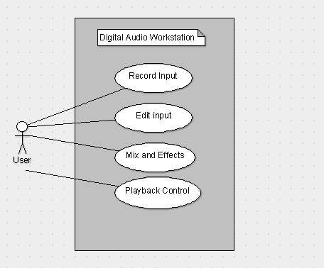
Figure 1: Audio creation through DAW
Run Scenario
- User Opens Software
- User either imports audio or records audio in software to manipulate
  - Edit input audio
  - Mix or add effects
  - Playback and analyze audio
- Then Once the user is satisfied they can save and export the audio to be used
Entity: Class Diagrams
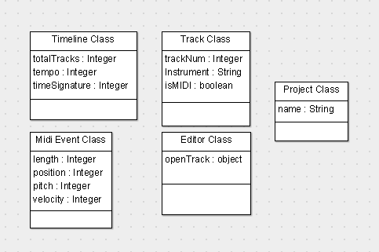
Figure 2: DAW Class Diagram
Class name/ description/ type
- Timeline Class
  - This class is built around the timeline. It controls the tempo and the time signature of the current project, as well as holds the number of tracks that currently exist on the timeline.
- Track Class
  - This class applies to each individual track that exists on the timeline. It had a track number, which is supplied by the Timeline Class, the instrument type if the track is a MIDI track, and a Boolean value to easily determine if the track is a MIDI track or not.
- Project Class
  - This class is for the currently open project. It stores the name of the project and handles any functions needed for saving and exporting.
- MIDI Event Class
  - This class applies to each individual MIDI event that exists on each MIDI track. Each MIDI event object holds a duration, position, pitch, and velocity.
- Editor Class
  - This class functions as the editor used to edit the MIDI events in MIDI tracks. It will hold a single MIDI track object and allow for the user to add, remove, and edit the MIDI events contained in said MIDI track.

Dynamic State Chart
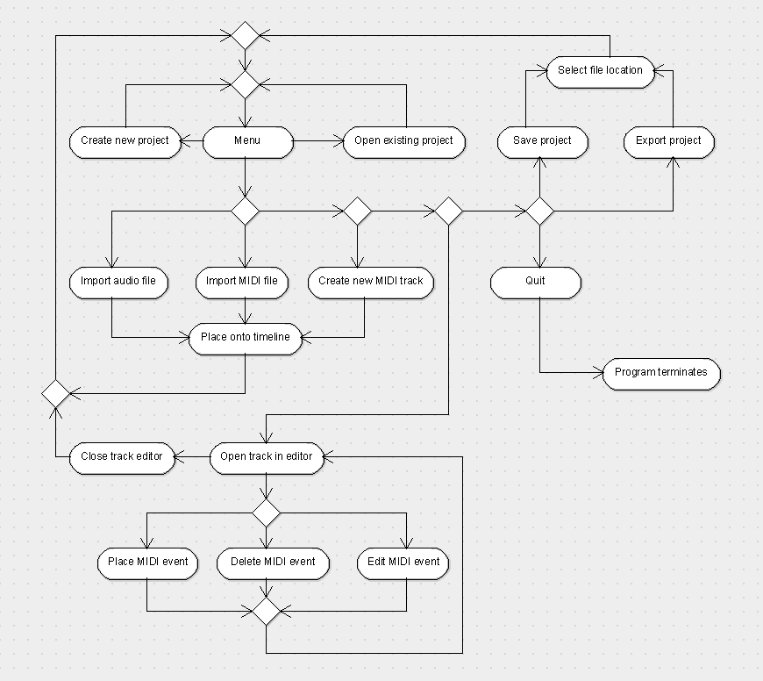
Figure 3: DAW State Chart
States
- The user runs the software on their PC
- The program starts at the menu with a blank timeline
- State 1: Create new project
  - The user clicks a button that creates a new project, removing anything that is currently on the timeline or elsewhere, leaving the timeline blank
- State 2: Open existing project
  - The user clicks a button that allows them to open a project that is already saved onto their computer. This will load all MIDI tracks and audio files that exist as part of that project onto the timeline for the user to continue working on it.
- State 3: Import audio file
  - The user clicks a button that allows them to import an existing audio file, then proceeds to state 6.
- State 4: Import MIDI file
  - The user clicks a button that allows them to import an existing MIDI file, then proceeds to state 6. If the MIDI file has multiple MIDI tracks, they will be separated into individual MIDI tracks.
- State 5: Create new MIDI track
  - The user clicks a button that creates a new MIDI track, then proceeds to state 6.
- State 6: Place onto timeline
  - The software automatically places the item onto the timeline in the next empty track.
- State 7: Open track in editor
  - The user selects a MIDI track to open in the MIDI editor. The software will display a zoomed in version of the MIDI track with more detailed information about the MIDI events contained within the MIDI track.
- State 8: Place MIDI event
  - The user creates a new MIDI event that is added to the MIDI track.
- State 9: Delete MIDI event
  - The user deletes an existing MIDI event from the MIDI track.
- State 10: Edit MIDI event
  - The user edits any MIDI event that is a part of the open MIDI track. This includes adjusting the pitch, the duration, the velocity, the timing
- State 11: Close track editor
  - The user closes the track editor which updates the corresponding MIDI track on the timeline to include any changes that were made while the editor was open.
- State 12: Save project
  - The user clicks a button to save the current project onto their computer. All MIDI tracks and audio files that are currently on the timeline are saved in a project folder.
- State 13: Export project
  - The user clicks a button to export the current project. All MIDI tracks and audio files that are currently on the timeline are compiled together into a single audio file that is saved to a location decided by the user.
- State 14: Quit
  - The user clicks a button to close the program.

Transitions
Upon opening the program, the user will be met with a blank timeline. From the menu at the top of the window, they will be able to select a number of different options, some leading directly back to the main screen, some opening the file manager to either open a file or save to a location before leading back to the main screen or simply quitting the program. From the main screen, the user will be able to open a MIDI track in the editor, which will open a new screen as the editor. This screen will remain until the user decides to close it, which will then take them back to the main screen.

Specification Dataflow Diagram
This is a specification data flow diagram that showcases a few of the interactions a user could have with the software. Shown here is the user opening a project, opening a track in the editor and using it to edit a MIDI track, closing the editor, and saving the project.(“programming MIDI”, 2020)
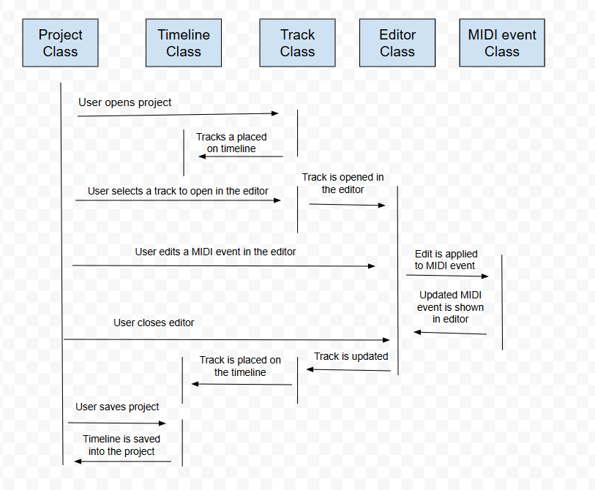
Figure 4:DAW Dataflow Diagram
- The user opens an existing project they have worked on and saved to their computer previously. This causes all the tracks that belong to that project to be placed onto the timeline.
- The user selects a track to open in the editor. If this track is a MIDI track, this action is successful, and the track is passed into the editor class.
- The user edits a MIDI event in the track they had opened using the editor. It passes any changes made to existing MIDI events, deletes any existing MIDI events that the user decides to delete, and creates new MIDI events that the user decides to create. These changes, removals, and editions are passed back to the editor so that the user may edit them further should they decide to.
- The user closes the editor. The track that is currently open in the editor is updated with the new information of changes made by the editor. The updated track is then placed back onto the timeline.
- The user saves the project so they can work on it more at a later time. The current timeline is saved into the project folder on the user’s computer.
Components/Tools Needed
The creation of this software will require several programs and tools as directed by one of the team members who is a musician who is most familiar with the development and necessities of Digital Audio Workstations(“Two Lies and a Truth”, 2025). Git will be a important tool to keep track of the program and to share amongst the developers while being able to rollback to any previous versions. All the developers will need some form of compiler to write the code and test the program as bug testing. There will is also a need to have another operating system-based computer such as a Linux machine to test the compatibility of the software. The team will also need to have a access to midi instruments to test the compatibility with them as peripherals that can interface into the software
Citations
Smith, B. (2025, August 22). Two Lies and a Truth [Review of Two Lies and a Truth]. Spotify; Benevolence Lost. https://open.spotify.com/track/0IZpv69vU4A9F7LDIl0tZ5?si=a2511c1b050243c7
javidx9. (2020, March 8). Programming MIDI [Video]. YouTube. https://www.youtube.com/watch?v=040BKtnDdg0
Create your best music | FL Studio. (n.d.). https://www.image-line.com/
Creative tools for music makers | Ableton. (n.d.). https://www.ableton.com/en/
Appendix: Glossary of Terms
MIDI track - a collection of MIDI events assigned to a single MIDI instrument that will “play” those MIDI events
Timeline - An area of the UI where MIDI tracks are displayed simultaneously
MIDI event - a section of a midi file that contains a note, the MIDI instrument that plays that note, the velocity of that note, and the amount of time between that note and the previous note
Time signature - A fraction value that represents the number of beats in a measure (top number) and what division/subdivision the measure is counted in (bottom number). Example: The time signature 3/4 will have three beats and the length of each beat will be a quarter note. The time signature 7/8 will have seven beats and the length of each beat will be an eighth note.
Velocity - The volume of a midi event, an integer in the range 0-127
MIDI instrument - A virtual instrument that reads MIDI events and plays sounds at the pitch, velocity, and timing defined by the MIDI events using a sound type specific to the MIDI instrument
MIDI peripheral - A physical instrument that has digital capabilities
MIDI file - A file that contains one or more MIDI tracks
Measure - A grouping of beats, of which the number of beats is defined by the time signature
Beat - a single segment of a measure
Note - a sound of a certain division/subdivision that has a pitch. A note is named by its pitch. This can be any one of the following, starting from the lowest pitch to the highest pitch: C, C#/Db, D, D#/Eb, E, F, F#/Gb, G, G#/Ab, A, A#/Bb, B. This letter is followed by a number that determines the octave.
Semitone - The figurative distance between two adjacent notes in terms of pitch. For example, the difference between E and F is one semitone, and the distance between G and A is two semitones as the note G#/Ab is between G and A
Sharp - a note is sharp if it is one semitone higher than the root letter. This is denoted by the # symbol. For example, a note that is one semitone higher than A would be A#
Flat - a note is flat if it is one semitone lower than the root letter. This is denoted by the letter ‘b’, lowercase is required. For example, a note that is one semitone lower than A would be Ab
Octave - a grouping of one of each of the 12 notes, starting at C, that increases sequentially until it ends at B. The higher the number of the octave, the higher the pitch of the notes in said octave are.
Division/subdivision - The length of a note measured in beats. This starts at a whole note (4 quarter notes), then can be divided by 2 sequentially to create shorter notes that are half the length of the next largest note. Whole note, half note, quarter note, eighth note, etc.
Tempo - The speed of the music, measured in beats per minute (BPM)
Project - The complete collection of MIDI files and audio files that are currently open on the timeline
Editor - A function of the program that will allow MIDI files to be edited by adding, removing, moving, and/or changing velocity of MIDI events in a track.
DAW (Digital audio workstation) - A software that allows for the creation of digital music and audio
Appendix: Team Details
This document was written in cooperation with all team members over the course of three weeks, it was a team effort under the leadership of Clayton Sanner. Contributors are outlined as such based on the sections they contributed to the most
- Alice Bruce was a major contributor to the “Description of document”, “Acceptance test criteria ”, and the “Components/Tools needed” segments of the document
- Brandon Smith was a major contributor to the “Entity:Class Diagrams”, “Dynamic: Statechart” and “Dataflow Diagrams” segments of the document
All other major sections of this document were developed during formal and informal meetings where the members contributed equally. In these meeting group members would provide assistance to each other and constructive criticism to help with the creation of the document. Proofreading was done as a group effort to provide the most grammatically correct and soundly formatted document. Figures were also done as a group effort with the decision to use them being unanimous. The team also was provided with assistance from a meeting with the writing center to provide feedback. Development on this project and the documents that will support it will continue as was detailed throughout this document
Appendix: Workflow Authentication
I, Clayton Sanner; Agree with the details defined in this document that as well as future work involving this project was done as stated per the description of this document
Signature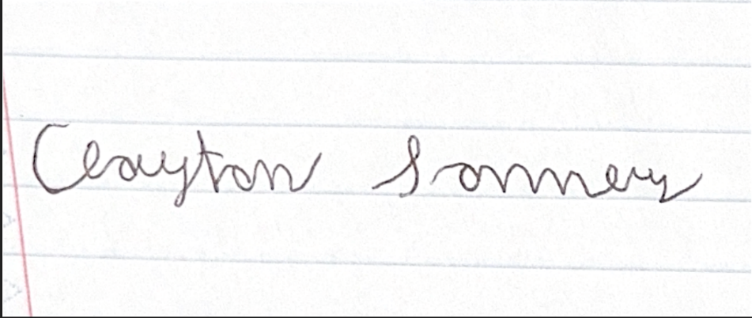
I, Brandon Smith; Agree with the details defined in this document that as well as future work involving this project was done as stated per the description of this document
Signature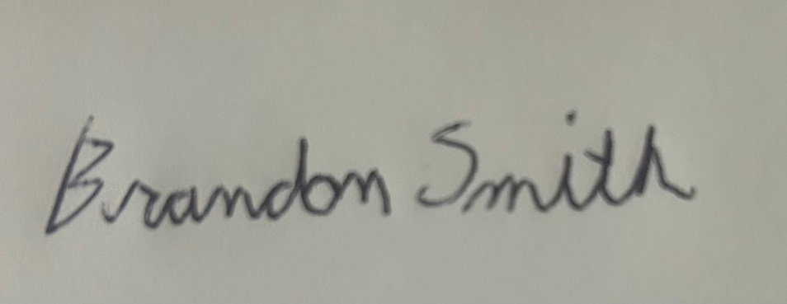
I, Alice Bruce; Agree with the details defined in this document that as well as future work involving this project was done as stated per the description of this document
Signature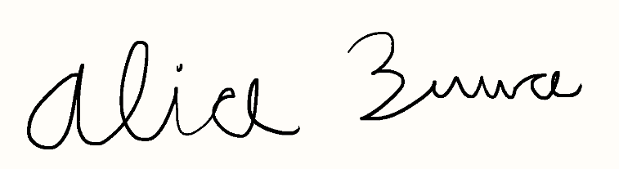

Appendix: Writing Center report
Clayton sent me the document ahead of time to look over and give notes to, to be better prepared since it was a longer document. Overall, the only thing I pointed out was an in text citation for a store, that I couldn't find a proper way to cite it, except referring to citing a webpage. Overall, no other issues of note within the document

